

MGM’s POLYTECHNIC, AURANGABAD
Micro Project Report
On
“ 3 IDIOTS (MOVIE) ”

Submitted in partial fulfillment for ‘I’ Scheme first semester
2019-2020
Diploma in
MECHANICAL ENGINEERING

BY

12151 AKASH MADHUKAR SHINDE (1915010322)
12152 MUNDIK ADITYA RATNESHWAR (1915010305)
12153 PATIL KSIHTIJ VIJAY (1915010282)
12154 MORE NARENDRA SHIVAJI (1915010331)
12155 DABHADE ADESH DNYANESHWAR (1915010319)
12156 FATPURE YOGESH JAGAN (1915010279)
12157 MOHAMMED SAAD SAYYED (1915010276)
12158 SHAIKH ANAS AKBAR JALALUDDIN (1915010372)
12159 JADHAV VAIBHAV SAKHARCHAND (1915010381)
12160 KULKARNI KEYUR HRISHIKESH (1915010374)
12161 AGRAWAL GAURAV SANJAY (1915010382)

Under the guidance of
Prof.GAIKWAD K.G.

Maharashtra State
Board of Technical Education, Mumbai
(Autonomous) (ISO-9001-2008) (ISO/IEC 27001:2013)

CERTIFICATE
This is to certify Mohammed Saad Sayyed, have successfully completed their Project work entitled “3 IDIOTS (MOVIE) ” in partial fulfillment for ‘I’ Scheme first semester Diploma in Mechanical Engineering of Maharashtra State Board of Technical Education the matter embodied in this report is a record of their team work carried out during academic year 2019-20.

Prof. GAIKWAD.K.G. Prof. PATIL S.S

GUIDE HOD
Applied science Department Applied science department

Principal
Dr. B. M. Patil

Title of Micro-Project

“ 3 idiots (movie) ”

- Brief Introduction

An Introduction to the 3 Idiots, an Award Winning Film It is from this context that the film 3 Idiots comes. 3 Idiots was a “superhit film” (3 Idiots Triumphs) directed by Rajkumar Hirani and released in 2009. The 3 Idiots is an award winning film with many awards were given specifically for its sound design.

- Review
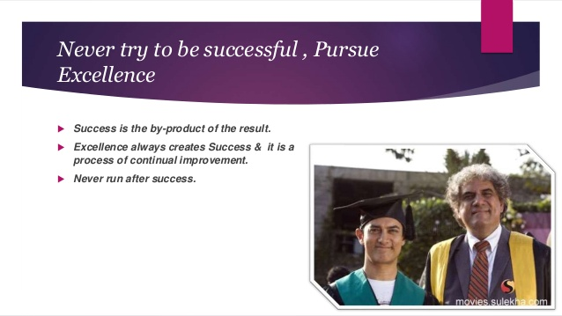
"Life is a race: If you're not fast enough, you'll get trampled," booms engineering college dean Viru Sahastrabudhhe (Boman Irani). The stakes are high: in India 2.0, students whose parents have sacrificed everything for their education are expected to reach the top.
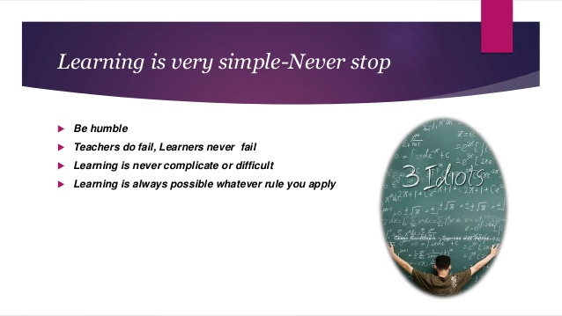

- Aim of the Micro-Project
- To show the film cast of the movie
- Characters of movie
- Review of movie
- Lesson taken from the movie

3.0 Action paln

S. No. | Details of activity | Planned Start date | Planned Finish date | Name of Responsible Team Members
 | Search of information about 3 idiots movie | 12/10/2019 | 13/10/19 | Saad
 | Study on project | 14/10/19 | 15/10/19 | Anas
 | Making of report | 16/10/19 | 19/10/19 | yogesh

4.0 Resources

S. No. | Name of Resource/material | Specifications | Qty | Remarks
 | Laptop dell | Intel core | 1
 | Youtube |  | -
 | Google  (wikipedia) | - | -

- Brief Description
In college, Farhan and Raju form a great bond with Rancho due to his positive and refreshing outlook to life. Years later, a bet gives them a chance to look for their long-lost friend whose existence seems rather elusive.
So, in summary, Imperial College of Engineering (ICE) Delhi in 3 Idiots
movie is a fictional college in Delhi. The shooting location of the movie 3
Idiots is in IIM (Indian Institute of Management) Bangalore, India which is one

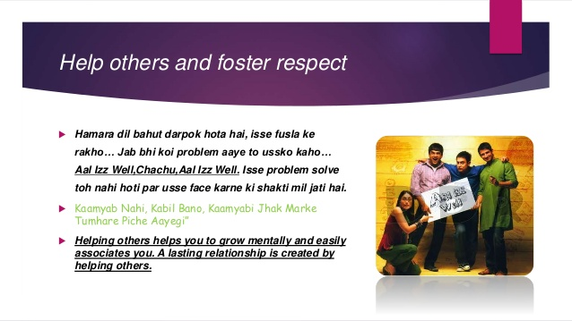

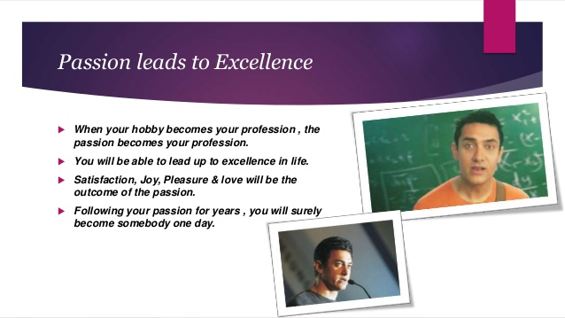
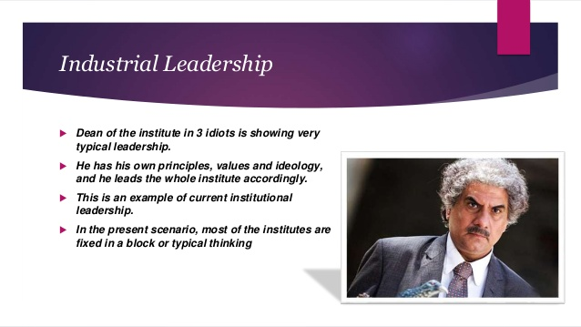
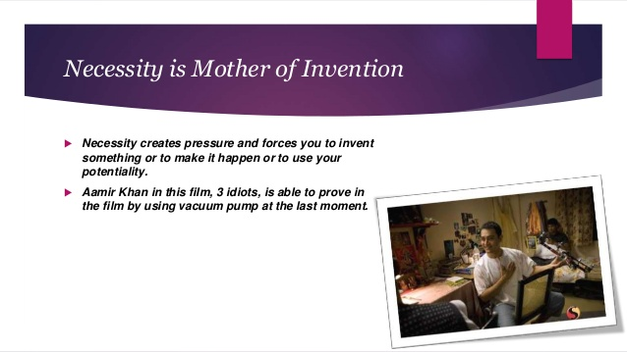

2.0 Aim of Micro Project
- We saw the film cast
- Characters of the movie
- Review of movie

3.0 Course Outcomes Integrated

Don't run behind the success: Don't run behind the success, achieve excellence first, the success will automatically come looking for you. Creativity: Be always creative in your answers, work & things you do which helps you become more capable of your own.

4.0 Actual Procedure Followed.
- we collect all the information about 3 idiots movie
- taking of review
- making of report

5.0 Actual Resources Used

S. No. | Name of Resource/material | Specifications | Qty | Remarks
 | Youtube(how to grouped and ungrouped data) dear sir
 | Google (wikipedia) | - | -
 | Laptop | - | -

**************

